Top 9 Healthy Ways to Cook Fruits & Vegetables

Cook It Up the Healthy Way - Which methods will you try this week?
- Bake …
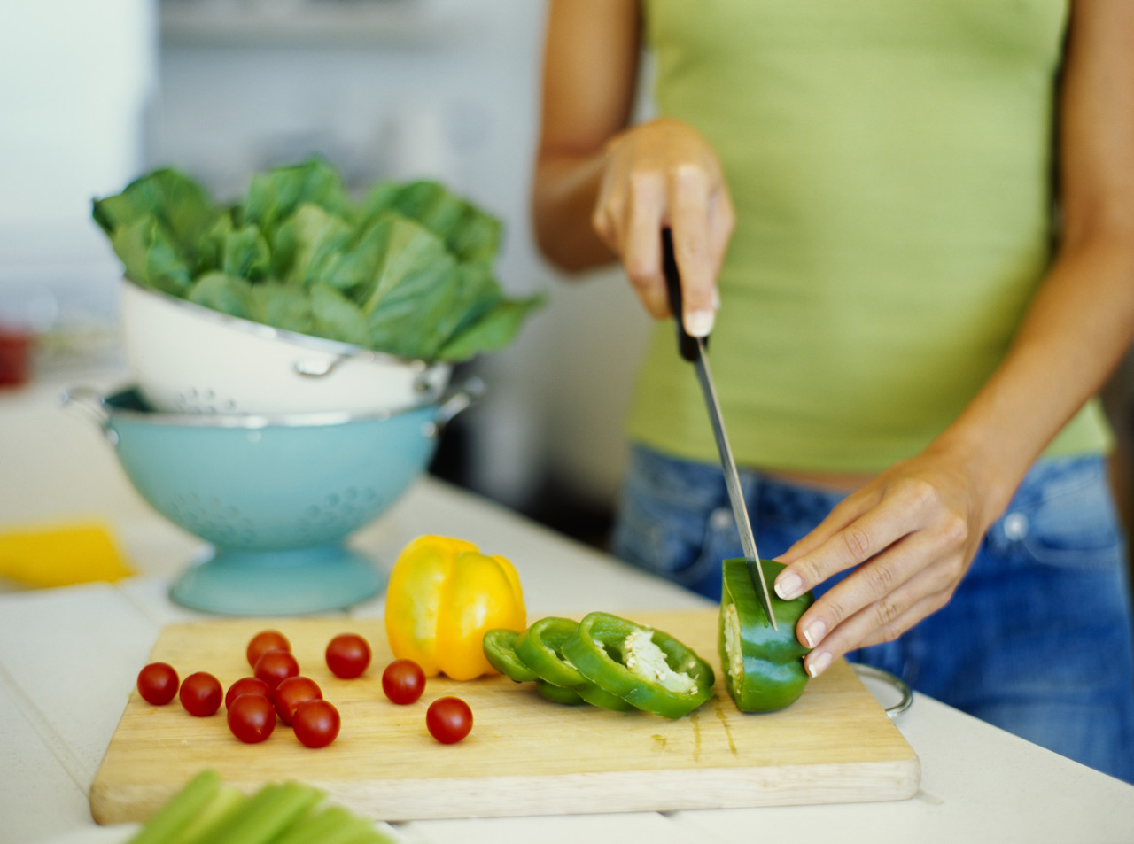
- Peaches for a sweet snack. Slice in half, drizzle on some honey and sprinkle with ginger and pecans.
- Winter squash, drizzle with approved fat and sprinkle with cinnamon.

- Boil …
1. Diced or crushed tomatoes in a vegetable or chicken
broth for the base of a homemade tomato soup!
2. Add fresh herbs and spices to make your unique recipe.
3. Turnips. Mash and season with salt and pepper.
4. Kale, and add a handful of chopped currants, salt and pepper.
5. Butternut squash and season with salt, pepper and a drizzle of approved fat.

- Steam …
- Artichokes for a long time (about an hour) to get flavorful leaves perfect for dipping! Try them
with a tasty almond pate.
2. Any of your favorite vegetables with citrus juice and zest added to the water to create bold, new
flavors. Try lemon juice with spinach, orange with broccoli or grapefruit with carrots!
3. A medley of vegetables and season with some herbs. Serve over rice.
4. Cabbage, and season with caraway seed, salt and pepper.
5. Green beans with chopped onion. Add a clove of garlic to cooking water.

- Stir-Fry …
1. Pineapple and mango in a honey ginger sauce and crumble with gluten-free oat topping for a fruit
crisp dessert.
2. Zucchini, yellow squash, diced tomatoes and mushrooms with butter and herbs. Add some diced
jalapeno for an extra kick and serve over brown rice.
3. Broccoli in ghee and chopped garlic. Add some capers for extra zip.
4. Frozen mixed veggies. Add a dash of low sodium, gluten-free soy sauce, or flavor with herbs.
5. Onions, peppers and zucchini. Throw in some red or black beans. Season with your favorite salsa
to give it a Southwestern flair. Serve over rice.

- Saute …
1. Apricots in a skillet with a little ghee or coconut oil until tender. Add orange slices, remove from
heat and serve for a fruity dessert.
2. Cauliflower with nutmeg and ghee after pre-steaming for a tasty twist on an old veggie.
3. Spinach with garlic and ghee or coconut oil.
4. Green and yellow summer squash with onion and garlic. Season with salt and pepper. For a
different twist, add chopped tomato and basil.
5. A variety of different colored peppers with onion. Serve as a side dish.

- Roast …
1. Red peppers in the oven at 450, turning every 15 minutes until done (blackened skins). Peel off
the skin and slice them, then drizzle in butter and garlic and refrigerate. A Perfect addition to any
salad, gluten-free sandwich or antipasto dish!
2. Some winter vegetables cut in large pieces – parsnips, turnips, rutabaga, beets, are some good
choices. Coat lightly with ghee or coconut oil, sprinkle with your favorite herbs, and roast at 425
for 30-40 minutes until tender and browned.
3. Brussels Sprouts drizzled lightly with ghee or coconut oil, and sprinkled with salt. Magnifique!

- Grill …
1. Mushrooms, bell peppers, onions and tenderloin for the perfect summer kabobs.
2. Pineapple, peaches or mango.
3. Asparagus and add to a salad of mixed greens, roasted peppers and toasted nuts.
4. Some eggplant, zucchini and portabella mushrooms to use in a wrap.

- Stew …
1. Peaches gently in cinnamon and water until tender. Perfect for an after dinner treat!
2. Cabbage with tomatoes and garlic to serve over rice for a unique side dish to any meal!
3. Classic vegetables such as, carrots, green beans, celery, and onions in canned tomato sauce.
Substitute canned beans like kidney beans or black beans for meat.
4. Onions, peppers, celery, and salsa. Serve over rice. Add some red or black beans and call it a meal!
5. Canned tomatoes, eggplant, peppers, and chickpeas. Add oregano and top with sliced olives.

- Blanch …
1. Almonds in water for 15 seconds and peel for a new twist on a healthy snack.
2. Basil and parsley leaves. Blend together with fax or hemp oil, pine nuts, garlic and a little lemon
juice for a great pesto!
3. Broccoli and cauliflower to use on a vegetable platter for snacks and appetizers.
4. Broccoli rabe in salted water to reduce bitterness. Then cook like broccoli.
5. Carrots, cauliflower, green beans, asparagus and broccoli. Marinate in Wahls Absolutely Fabulous
Greek/House Dressing and serve cold. If desired, add other veggies like onions, mushrooms and
peppers.

